TASMANIAN INDUSTRIAL COMMISSION

Industrial Relations Act 1984
s55(2) application for approval of an industrial agreement

Minister administering the State Service Act 2000
and
The Association of Professional Engineers, Scientists and Managers, Australia
and
Australian Education Union, Tasmanian Branch
and
The Community and Public Sector Union (State Public Sector Federation
Tasmania) Inc
and
Health Services Union, Tasmania Branch
and
United Voice, Tasmanian Branch
(T14458 of 2016)

PUBLIC SECTOR UNIONS WAGES AGREEMENT 2016

PRESIDENT D J BARCLAY HOBART, 23 DECEMBER 2016

Industrial agreement - application approved - operative from date of registration - forwarded to Registrar for registration

DECISION

[1] On 19 December 2016, the Minister administering the State Service Act 2000 (MASSA) lodged with the Registrar, pursuant to Section 55(2) of the Industrial Relations Act 1984 (the Act), the Public Sector Unions Wages Agreement 2016 (the Agreement).

[2] At the hearing in Hobart on 22 December 2016, Mr F Ogle appeared on behalf of the MASSA, Ms R Madsen appeared on behalf of the Australian Education Union, Tasmanian Branch (AEU), Mr T Lynch appeared on behalf of The Community and Public Sector Union (State Public Services Federation Tasmania) Inc (CPSU) and Mr R Moore appeared on behalf of the Health Services Union, Tasmania Branch (HSU).

[3] Mr Ogle submitted that the Agreement was part of a three stage process of reaching agreement with the unions:

a. The approval of the agreement;

b. Variations to the relevant award; and

2

c. Commitments contained in a letter from Mr Ogle on behalf of the Head of the State Service regarding ongoing negotiations in relation to employment related matters dated 21 December 2016 (the Commitment Letter).

[4] A substantial part of the Agreement reflected the previous wages agreement. There was however a number of matters of importance referred to in the Commitment Letter to be negotiated. In addition the parties negotiated significant matters to be reflected in variations to the award relating to family violence and bereavement conditions.

[5] Significantly the Agreement provided for wages increases over the life of the agreement.

[6] Mr Ogle commended the Agreement to the Commission.

[7] Mr Lynch acknowledged Mr Ogle's submissions. He noted there would be no disadvantage to employees as it was agreed that the 2013 agreement not be retired. He also noted the significance of the three step process and of the Commitment Letter.

[8] Mr Moore agreed with Mr Ogle and Mr Lynch and noted for his members the significance of the Night Shift Allowance.

[9] All parties submitted that it was in the public interest that the agreement be approved and that employees would not be disadvantaged through the approval of the agreement.

[10] I am satisfied that the agreement is consistent with the public interest requirements of the Act, does not disadvantage the employees concerned, and the term of the agreement does not exceed 5 years.

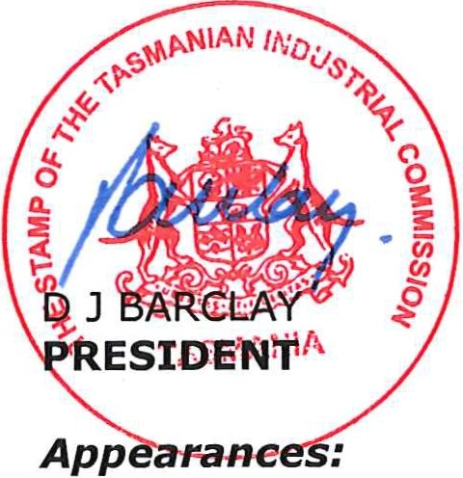[11] Pursuant to s55(4) the agreement is approved with an operative date from the date of registration and shall remain in force until 30 June 2018. The file will now be referred to the Registrar for registration of the Agreement in accordance with the requirements of s56(1) of the Act.

Mr FOgle for MASSA Ms R Madsen for AEU Mr T Lynch for CPSU Mr R Moore for HSU

Date and place of hearing:
2016
22 December
Hobart

