TASMANIAN INDUSTRIAL COMMISSION

Industrial Relations Act 1984
s55(2) application for approval of an industrial agreement Minister administering the State Service Act 2000 and
The Australian Workers' Union, Tasmanian Branch
(T14463 of 2016)

AWU PUBLIC SECTOR UNION WAGES AGREEMENT 2016

PRESIDENT D J BARCLAY HOBART, 23 DECEMBER 2016

Industrial agreement - application approved - operative from date of registration - forwarded to Registrar for registration

DECISION

[1] On 20 December 2016, the Minister administering the State Service Act 2000 (MASSA) lodged with the Registrar, pursuant to Section 55(2) of the Industrial Relations Act 1984 (the Act), the AWU Public Sector Union Wages Agreement 2016 (the Agreement).

[2] At the hearing in Hobart on 22 December 2016, Ms J Fitton appeared on behalf of the MASSA, and Mr K Midson appeared on behalf The Australian Workers' Union, Tasmania Branch (AWU).

[3] Ms Fitton noted that the Agreement related to employees employed by the Department of Primary Industries Parks Water and Environment. She submitted that the Agreement was substantially the same as the previous agreement however with the addition of lactation breaks/facilities and lease novation clauses.

[4] Mr Midson noted that the 2013 agreement would not be retired thus preserving employees' entitlements. He noted 100% approval by those to be covered by the Agreement.

[5] Both parties submitted that it was in the public interest that the agreement be approved and that employees would not be disadvantaged through the approval of the agreement.

[6] I am satisfied that the agreement is consistent with the public interest requirements of the Act, does not disadvantage the employees concerned, and the term of the agreement does not exceed 5 years.

2

[7] Pursuant to sSS( 4) the agreement is approved with an operative date from the date of registration and shall remain in force until 30 June 2018. The file will now be referred to the Registrar for registration of the Agreement in accordance with the requirements of s56(1) of the Act.

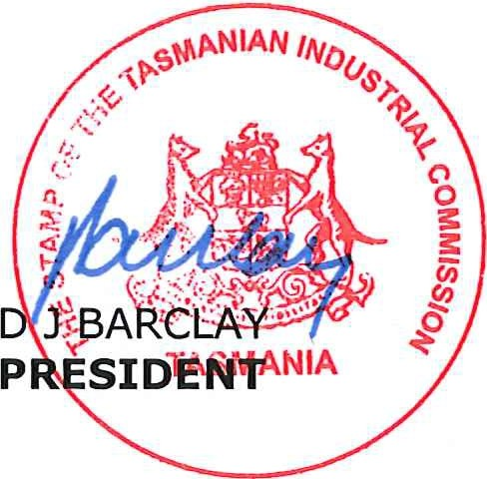
Appearances:
Ms J Fitton for MASSA
Mr K Midson for AWU

Date and place of hearing:
2016
22 December
Hobart

