TASMANIAN INDUSTRIAL COMMISSION

Industrial Relations Act 1984
s23(1) application for award or variation of award

The Minister administering the State Service Act 2000
(T14473 of 2017)

FACILITIES ATTENDANTS (TASMANIAN STATE SERVICE) AWARD

PRESIDENT D J BARCLAY HOBART, 24 January 2017

Award variation - availability and recall – time off in lieu of overtime - consent application - consent order issued - operative date 1 December 2016

DECISION

[1] On 17 January 2017, The Minister administering the State Service Act 2000 (MASSA) lodged with the Registrar, pursuant to Section 23(1) of the Industrial Relations Act 1984 (the Act), an application to vary the Facilities Attendants (Tasmanian State Service) Award.

[2] At the hearing in Hobart on 24 January 2017, Mr M Watson appeared on behalf of the MASSA and Mr L Hills appeared on behalf of United Voice, Tasmanian Branch (UV).

[3] Mr Watson sought the following variations to the Award:

a. Part V - Hours of Work - Delete existing clause 6 - Call Back- replace with a new Clause 6 entitled Availability and Recall;

b. Part V – Hours of Work - insert new clause 10 after clause 9 Travelling time - entitled Time Off in Lieu of Payment for Overtime.

- Both parties submitted the variations sought do not offend the public interest, do not disadvantage those employees covered by the Award and recommended the variations to the Commission

- I am satisfied that the variations are in the public interest and that no employees are disadvantaged.

- The application is granted and pursuant to s24 and 36 of the Act the Award is varied in accordance with the application. The variations to the award are operative from1 December 2016.

- An order reflecting this decision is to follow.

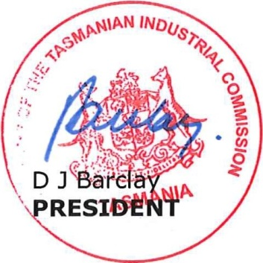
Appearances:
Mr M Watson for MASSA
Mr L Hills for UV

Date and place of hearing:
2017
24 January
Hobart

