TASMANIAN INDUSTRIAL COMMISSION

Industrial Relations Act 1984
s55(2) application for approval of an industrial agreement Minister administering the State Service Act 2000 and
The Community and Public Sector Union (State Public Services Federation
Tasmania) Inc

and

United Voice, Tasmanian branch
(T14469 of 2016)

CORRECTIONAL OFFICERS AGREEMENT 2016

PRESIDENT D J BARCLAY HOBART, 23 DECEMBER 2016

Industrial agreement - application approved - operative from date of registration - forwarded to Registrar for registration

DECISION

[1] On 20 December 2016, the Minister administering the State Service Act 2000 (MASSA) lodged with the Registrar, pursuant to Section 55(2) of the Industrial Relations Act 1984 (the Act), the Correctional Officers Agreement 2016 (the Agreement).

[2] At the hearing in Hobart on 22 December 2016, Mr B Charlton appeared on behalf of the MASSA, Mr T Lynch appeared on behalf of The Community and Public Sector Union (State Public Services Federation Tasmania) Inc (CPSU) and Mr L Hills appeared on behalf of United Voice, Tasmania Branch (UV).

[3] Mr Charlton submitted that the Agreement was largely unchanged from the 2013 agreement. He did note however that the higher duties allowance was not available for employees working less than 5 days in the higher role under the old agreement. Under the Agreement the allowance will be payable where an employee works for a full shift or longer in the higher role. He noted new wage related allowances, lactations breaks/facilities and changes to the classification system. He noted that the employees would have the benefit of the amendments to the relevant award including expanded access to bereavement leave and a separate Family Violence Leave entitlement.

[4] Mr Lynch adopted the submissions and noted 81% approval of the proposed agreement.

2

[5] Mr Hills adopted the submissions of both Mr Charlton and Mr Lynch. He noted 89%
approval of the Agreement.

[6] All parties submitted that it was in the public interest that the agreement be approved and that employees would not be disadvantaged through the approval of the agreement.

[7] I am satisfied that the agreement is consistent with the public interest requirements of the Act, does not disadvantage the employees concerned, and the term of the agreement does not exceed 5 years.

[8] Pursuant to sSS( 4) the agreement is approved with an operative date from the date of registration and shall remain in force until 31 December 2018. The file will now be referred to the Registrar for registration of the Agreement in accordance with the requirements of s56(1) of the Act.

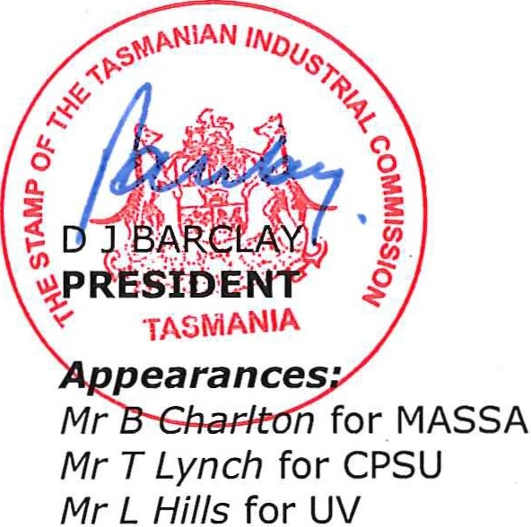

Date and place of hearing:
2016
22 December
Hobart

